Birdy Flap

An action game where you have to pass through pipes and get your best score. You will be able to buy some skins using the past tubes as currency.

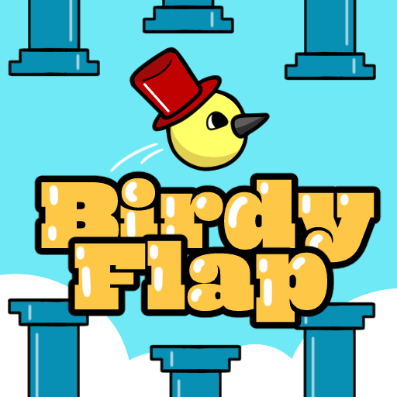

Menu:

There will be shown your character, with the selected skin at the moment of opening the menu.

There are many options you can touch:

Start the game: will load the gameplay scene.

Credits: will show the credits.

Quit: will partially close the game.

Achievements: will show the achievements screen from play games.

Shop: will Load the store scene.

Log: will show the log related panel.

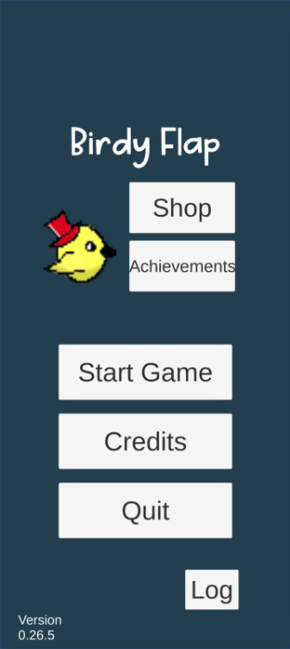

Gameplay:

Every time you tap the screen, your character, a little bird, will jump.

There are pipes that will act as obstacles. You have to avoid them to win points/jumps that will be used as currency.

When you touch an obstacle, the game will be over.

There is no pause because the gameplay is too short.

On Game Over, you will see your score, your total currency and your max score respectively. Then you will be able to open the store, open the achievements tab, go back to menu, or replay.

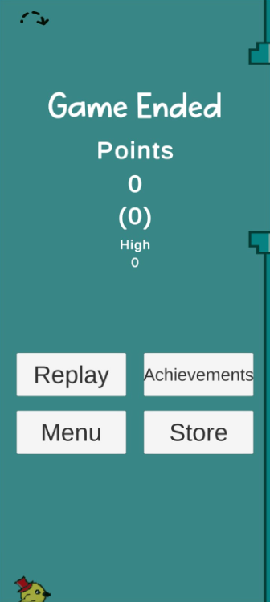

Store:

You will be able to buy skins to personalize your character.

Buyable skins are different hat, beak and eyes colors.

You will be able to equip your skins right in that section.

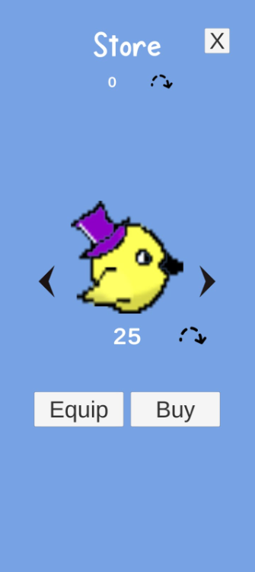

Log:

There are 4 buttons:

Delete Log: Will erase completely the log.

Get Jumps: Will give you jump randomly from 1 to 5 every time you touch it.

Hard Reset: Will reset the game progress.

X: Will close the panel.

